Appendix J iSeeTV – an example of a Personal live Video Remote Tutoring Service

This information has been supplied by iSeeTV. Any claims made by them have not been verified nor does this study specifically endorse this product. It is just given as an example of what is now possible.

A proposition for e-learning with iSeeTV

What it is
iSeeTV is a service that enables audio, visual and multimedia contact between an organisation’s call centre adviser/tutor and an end-user student who converses by telephone and sees the adviser and personalised content on TV or PC. Unlike broadcast that delivers one signal to many homes, iSeeTV is narrowcast and delivers one signal to one device. It also supports multi-casting to closed user groups such as schools and universities and can be two-way using web cams. iSeeTV provides live synchronous interaction between the tutor and the learner(s).

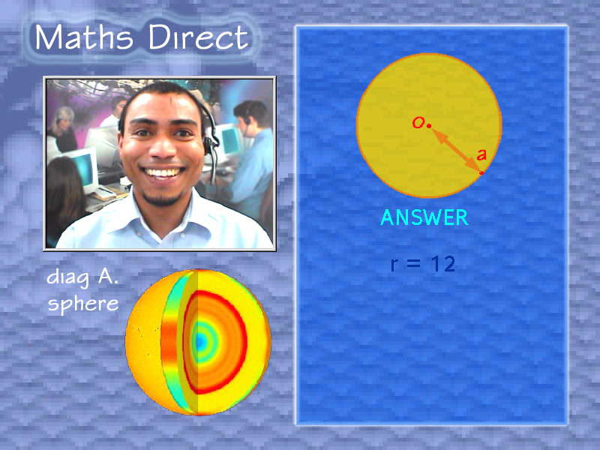

Multi-channel Offering
iSeeTV is not limited to digital cable TV. In fact it can be implemented through a number of delivery channels including DSL, VPNs, WiFi, broadband and narrowband Internet; and soon to PDAs and mobile phones. This allows organisations to reach their students in any location they choose, whether in a library, a kiosk on the high street, in the home or in a chosen place of study such as community centres, offices or factories, all at a time to suit the tutor or student.

Benefits
- iSeeTV allows organisations to deliver a quality, personal service to their students, on TV or PC, offering assistance with complex subjects or information, increasing staff efficiency and giving a quality distance learning experience
- iSeeTV transforms the relatively impersonal world of the Internet into a much richer experience of a real person on-screen delivering personalised, multimedia content
- Access points can be almost anywhere to suit the student, giving world-class educational opportunities to a wider audience of learners, assisting the governments stated desire to promote ‘lifelong learning’
- iSeeTV enables previously uneconomic training to become cost-effective as tutors and students do not have to be in the same geographic location but can join together as ‘virtual groups’. A good example of this is an employer’s training delivered to the desktop, saving money on time and travel
- iSeeTV can integrate well with existing learning and teaching methods
- iSeeTV sessions delivered to TV can be recorded by the student
- iSeeTV can incorporate all the essentials of two-way teaching and student feedback with tablets, shared white boards and multimedia presentations
- iSeeTV’s differentiator is that it delivers a ‘live’ video feed and multimedia content that gives a truly interactive experience between teacher and student(s)

Success in business sectors other than education
iSeeTV has been successfully piloted in retail, supermarket, financial and healthcare services. It is also appropriate in a wide range of business sectors including travel, distance learning, government and information services; in fact, any commercial or non-commercial organisation that would benefit from the assistance of a human adviser who can show personalised multimedia content whilst at the same time enriching the customer experience by appearing one-to-one on TV or PC

Consumer feedback – do they like iSeeTV?
The very successful trial of iSeeTV that went ‘live’ to 52,000 Telewest digital TV subscribers in the Birmingham area, over a period of nine months, showed very positive feedback from users. Organisations taking part were NHS Direct, AMP Pearl, Debenhams and Iceland foods. The NHS Direct ‘InVision’ service, where an NHS Nurse was able to give a live onscreen consultation with patients, was voted ‘best interactive TV service’ at the International EMMAs awards (Electronic Multi-Media Awards) in 2001.

Highlights of consumer feedback from the pilot:

- 59% of those who tried iSeeTV would use it again
- 50% of the sample said they would try other services of interest to them using iSeeTV including distance learning
- 11% of subscribers accessed the services

The key learning point from the trial was that customers who tried the service loved it and would use it again. It is easy for consumers to use and requires nothing more than a telephone and TV (or PC).

iSeeTV implementations
On March 31st 2003 iSeeTV will launch two broadband services in the USA. Ball State University is the third largest university in Indiana and will be delivering two new services to students in their dorms. With the first service students will be able to have a private consultation on medical matters during out-of-clinic hours with a live onscreen nurse. The second service will provide career advice and counselling to student nurses, with planned roll out of an e-learning service to off-site undergraduate and graduate nurses later this year.

For further information visit the website: www.iseetv.net
For a ‘live’ demonstration, contact Pam Whittle on 01252 776777

